**Java Assignment 7**

Rational Number Program With Exception Handling

By:

Vaibhav Jaiswal

PRN:17070122071

Batch:CS-4

Branch: CSE

SY CSE (Batch of 2017-2021)

**CODE**

import java.lang.*;

import java.util.*;

class RationalNo{

    private int numer , denom ;

    RationalNo(){

        this.numer = -1 ;

        this.denom = -1 ;

    }

    RationalNo(int numer , int denom){

        this.numer = numer ;

        this.denom = denom ;

    }

    public static RationalNo simplify(RationalNo rno){

        for(int i = 20 ; i >= 2 ;i--){

            if(rno.numer%i == 0 && rno.denom%i==0){

rno.numer = rno.numer/i ;

rno.denom = rno.denom/i ;

}

        }

        return rno ;

}

public static RationalNo addNo(RationalNo num1 ,RationalNo num2){

RationalNo num3 = new RationalNo(1,1) ;

num3.numer = (num1.numer*num2.denom)+(num2.numer*num1.denom) ;

        num3.denom = (num1.denom)*(num2.denom) ;

        return RationalNo.simplify(num3) ;

    }

    public static RationalNo subtNo(RationalNo num1 ,RationalNo num2){

RationalNo num3 = new RationalNo(1,1) ;

num3.numer = (num1.numer*num2.denom)-(num2.numer*num1.denom) ;

        num3.denom = (num1.denom)*(num2.denom) ;

        num3 = RationalNo.simplify(num3) ;

        return num3 ;

    }

    public static RationalNo mulNo(RationalNo num1 ,RationalNo num2){

RationalNo num3 = new RationalNo(1,1) ;

num3.numer = (num1.numer) * (num2.numer);

        num3.denom = (num1.denom) * (num2.denom) ;

        num3 = RationalNo.simplify(num3) ;

        return num3 ;

    }

    public static RationalNo divno(RationalNo num1 ,RationalNo num2){

RationalNo num3 = new RationalNo(1,1) ;

num3.numer = (num1.numer*num2.denom);

        num3.denom = (num1.denom)*(num2.numer) ;

        num3 = RationalNo.simplify(num3) ;

        return num3 ;

    }

    public String toString(){

        return (" " + this.numer + " / " + this.denom + " ") ;

    }

    public static float convertToFloat(RationalNo a){

        return ((float)a.numer/(float)a.denom);

    }

    public static void compare(RationalNo a , RationalNo b ){

        if ((a.numer/a.denom) > (b.numer/b.denom)){

            System.out.println(a + " is greater than "+ b);

        }

        else if ((a.numer/a.denom) < (b.numer/b.denom)){

            System.out.println(a + " is smaller than "+ b);

        }

        else if ((a.numer/a.denom) == (b.numer/b.denom)){

            System.out.println(a + " is Equal to "+ b);

        }

    }

}

class Driver{

    public static void main(String[] args) {

        try {

            int i = Integer.parseInt(args[0])/Integer.parseInt(args[1]);

            int k = Integer.parseInt(args[2])/Integer.parseInt(args[3]);

            RationalNo rno1 = new RationalNo(Integer.parseInt(args[0]),Integer.parseInt(args[1]));

            RationalNo rno2 = new RationalNo(Integer.parseInt(args[2]),Integer.parseInt(args[3]));

            System.out.println("addition :" + RationalNo.addNo(rno1 , rno2));

            System.out.println("subtraction :" + RationalNo.subtNo(rno1 , rno2));

            System.out.println("Multiplication :" + RationalNo.mulNo(rno1 , rno2));

            System.out.println("Division :" + RationalNo.divno(rno1 , rno2));

            System.out.println("Float point conversion of " +rno1+ " is : "+ RationalNo.convertToFloat(rno1));

            System.out.println("Float point conversion of " +rno2+ " is : "+ RationalNo.convertToFloat(rno2));

            RationalNo.compare(rno1, rno2);

        }

        catch (ArithmeticException e) {

            System.out.println("Arithematic Expression error : Divide by zero \nPlease Enter proper inputs and try again") ;

        }

        catch (NumberFormatException e){

            System.out.println("Number Format Mismatch error : Please enter Numbers only\nPlease Enter proper inputs and try again") ;

        }

    }

}

**Output**

Input was 1234/5678 & 8765/4321 :

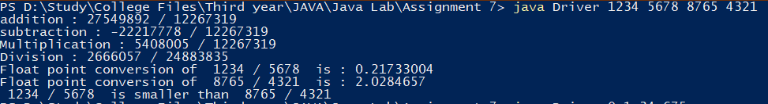

Input was 0/1 & 34/675 :

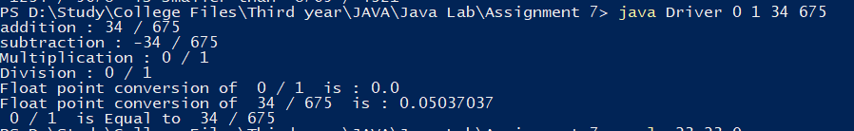

Input was apple/23 & 23/65 :



Input was 55/0 & 23/65 :

